Nesterov Accelerated Gradient (NAG) Explained in Detail | Animations | Optimizers in Deep Learning
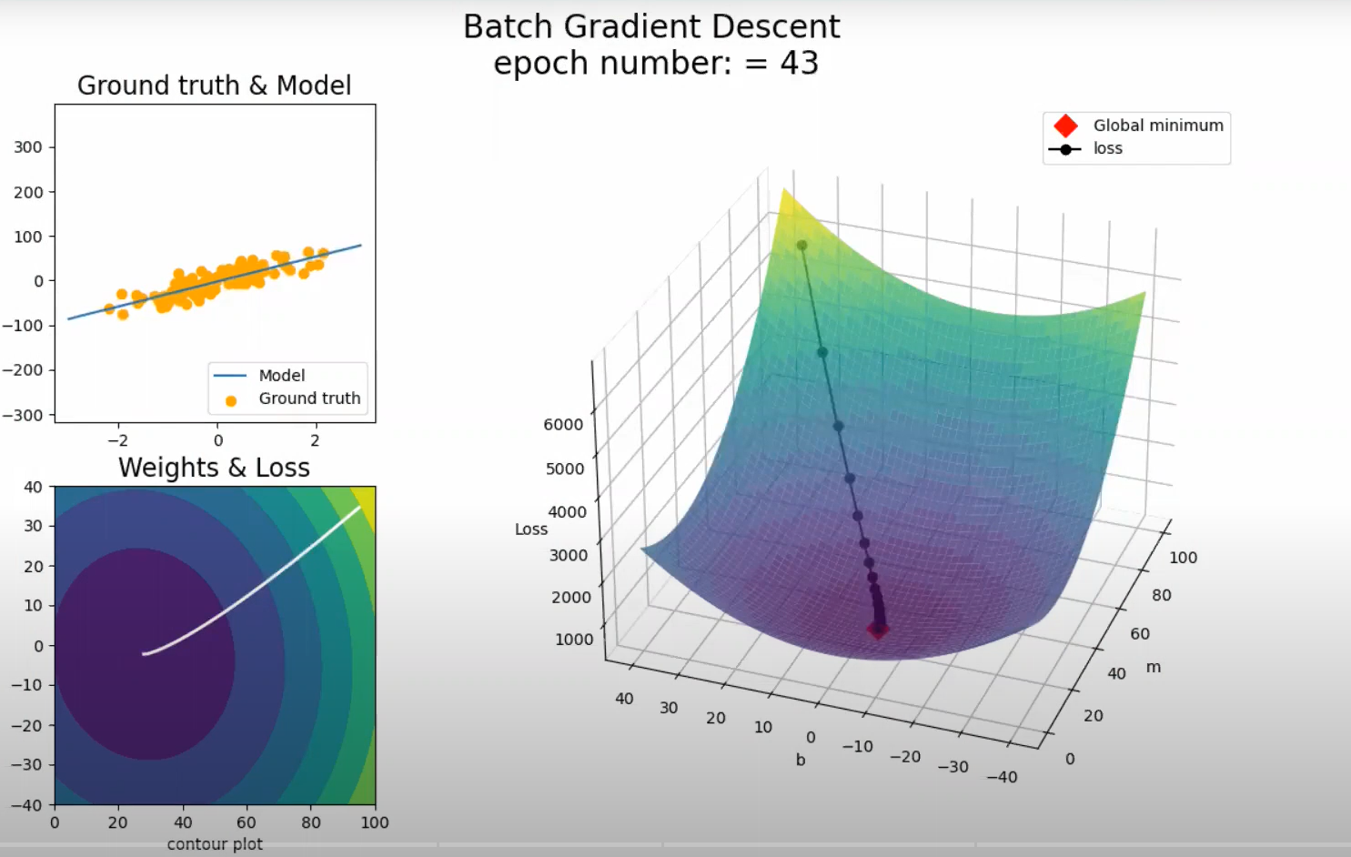
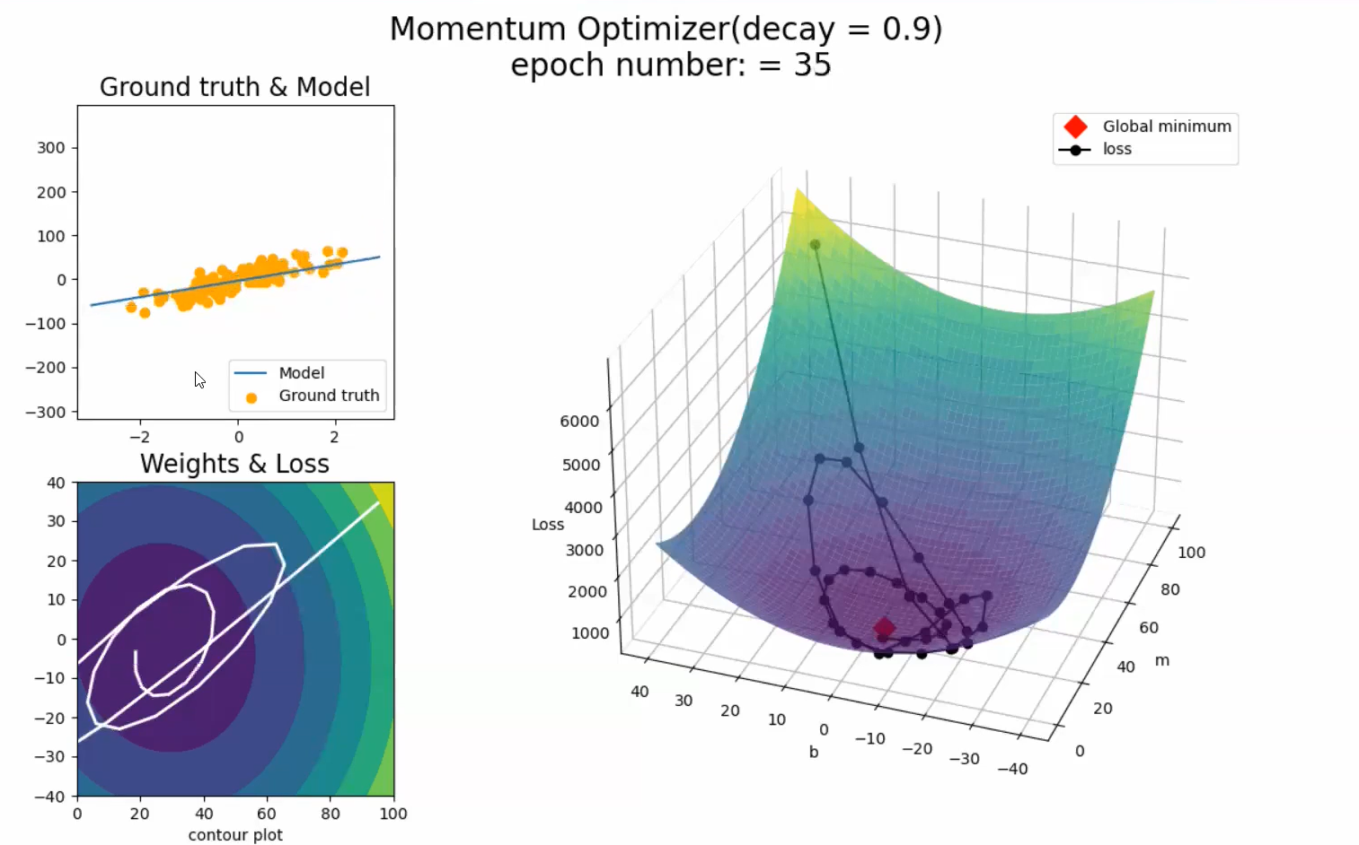

AdaGrad Explained in Detail with Animations | Optimizers in Deep Learning Part 4
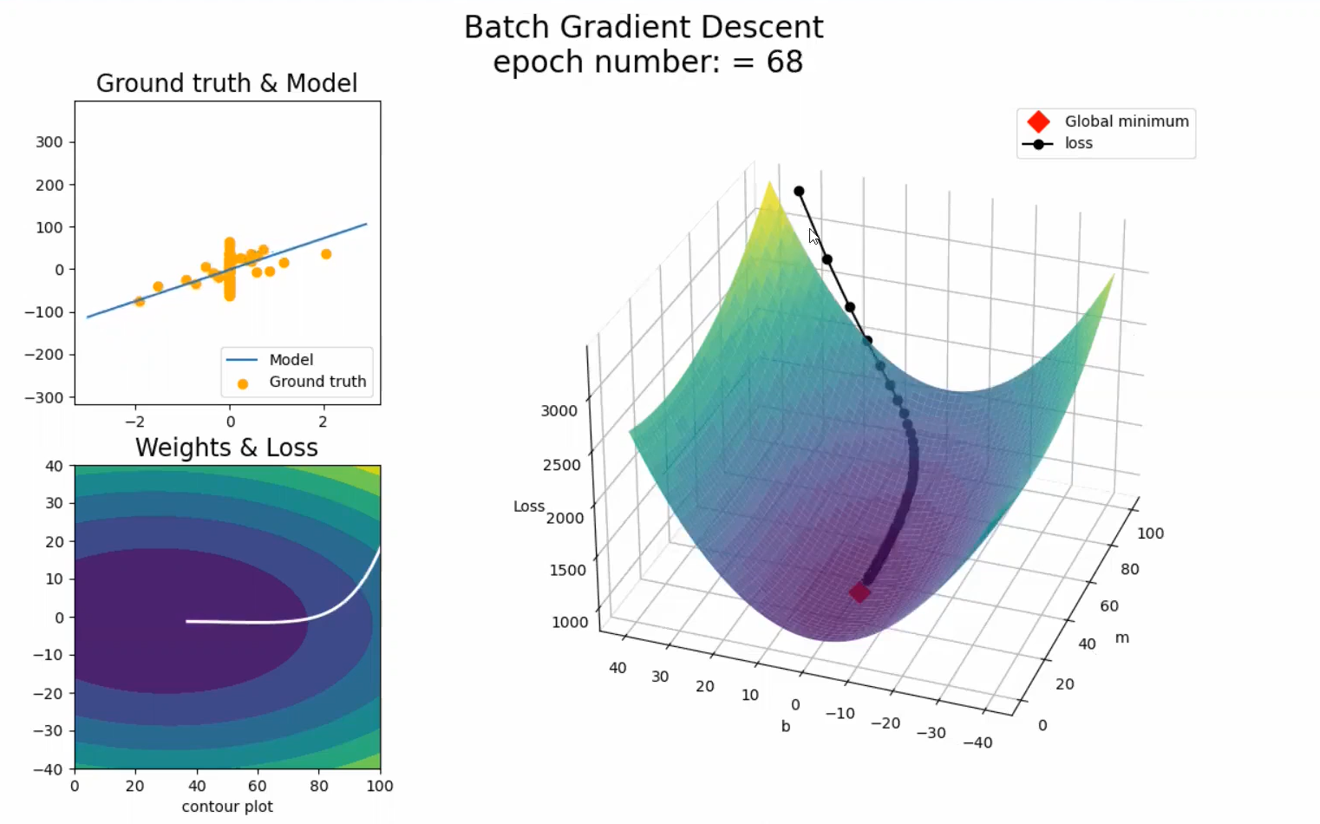

M is coefficient of x which is sparse. So movement is towards b here. X sparse hai isliye suru me changes sirf b dikh rhe hai visuals me.
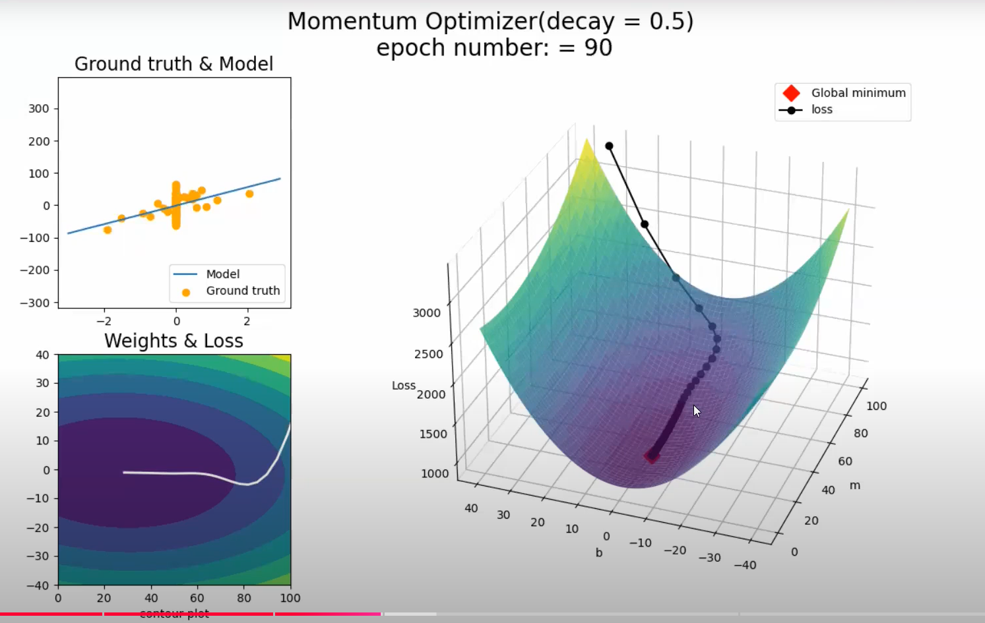
Dono me ek hi problem hai.
Isi ko solve Adagrad karta hai.
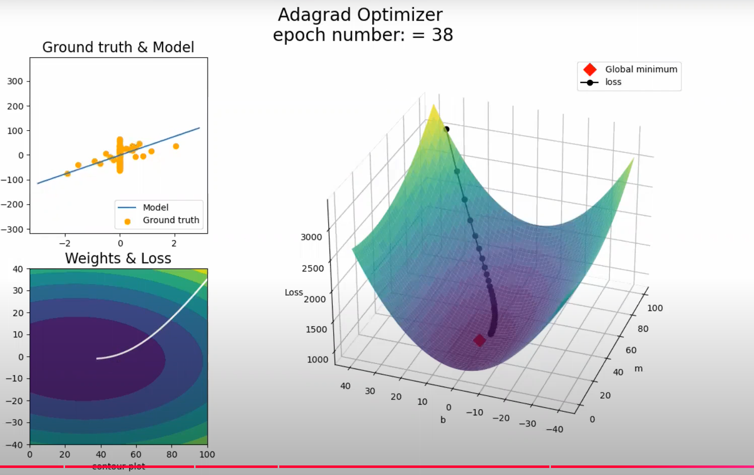

RMSProp Explained in Detail with Animations | Optimizers in Deep Learning Part 5
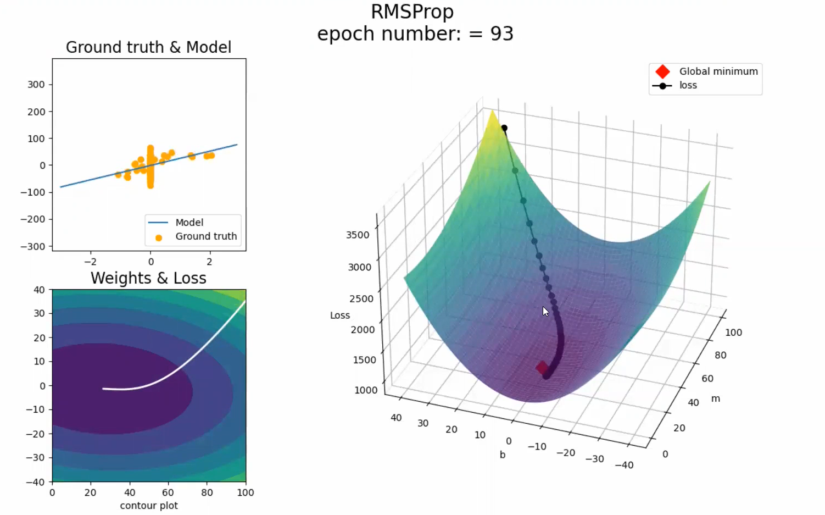

Adam Optimizer Explained in Detail with Animations | Optimizers in Deep Learning Part 5
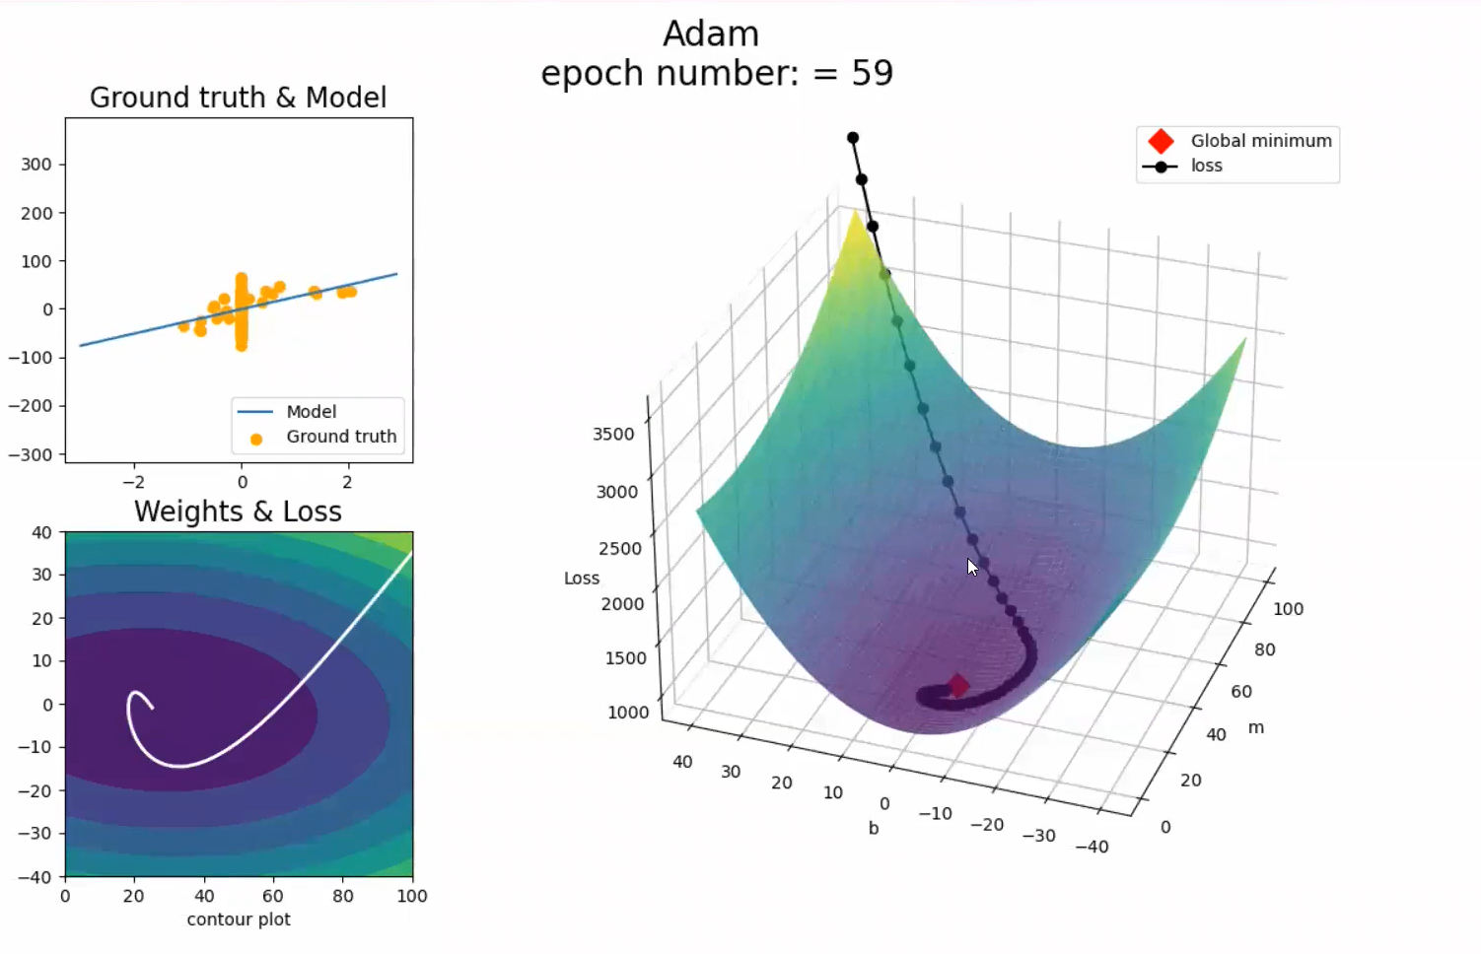
Convex problem utna samjh nhi aayega.
But non-convex / complex NN me ache se samjh me aayega.
Yha pe beech me se curve aa rha hai, jo ki best soln hai compared with GD, Momentum.

Keras Tuner | Hyperparameter Tuning a Neural Network
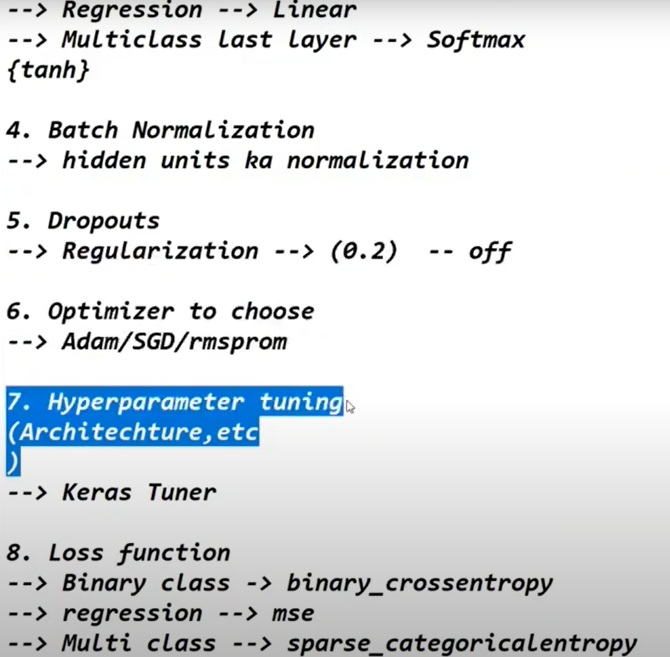
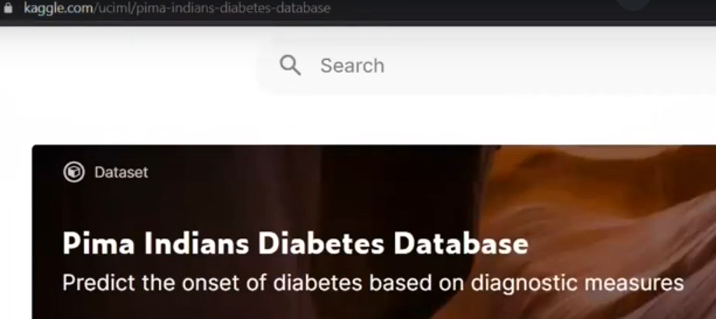
With the help of keras tuner we can automate hyperparameter tuning of below things.
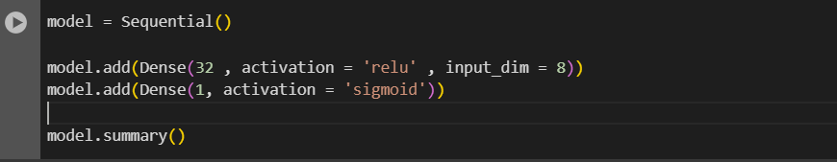
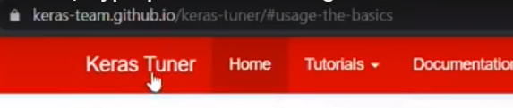
What is Convolutional Neural Network (CNN) | CNN Intution
Application
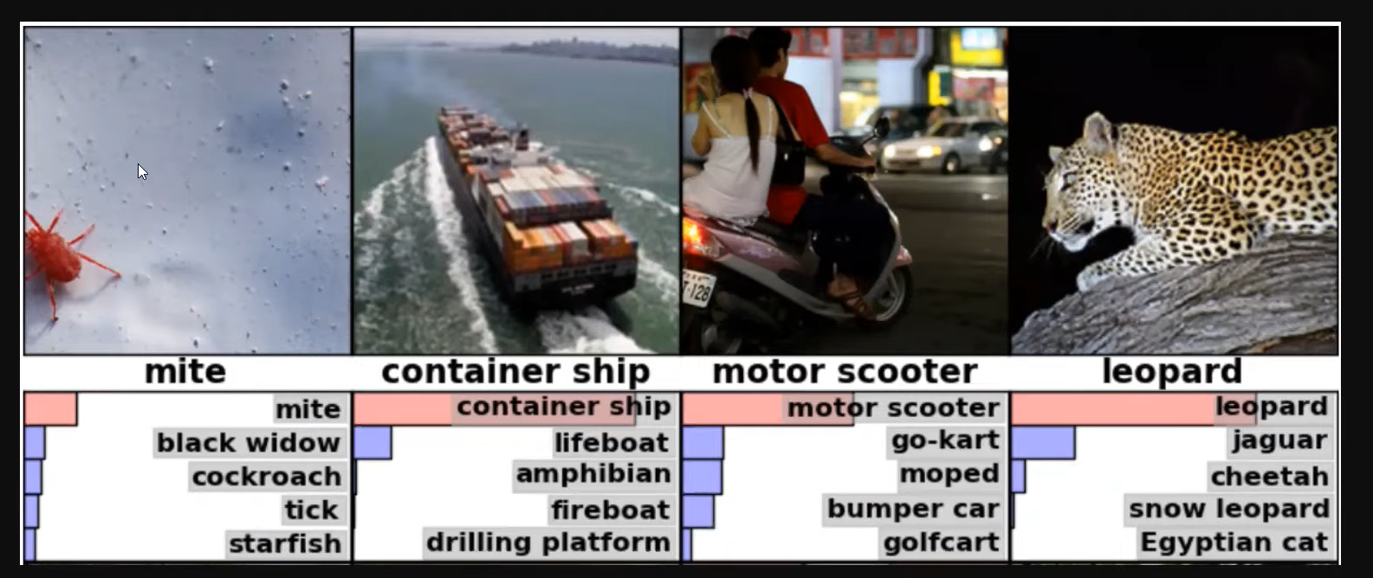
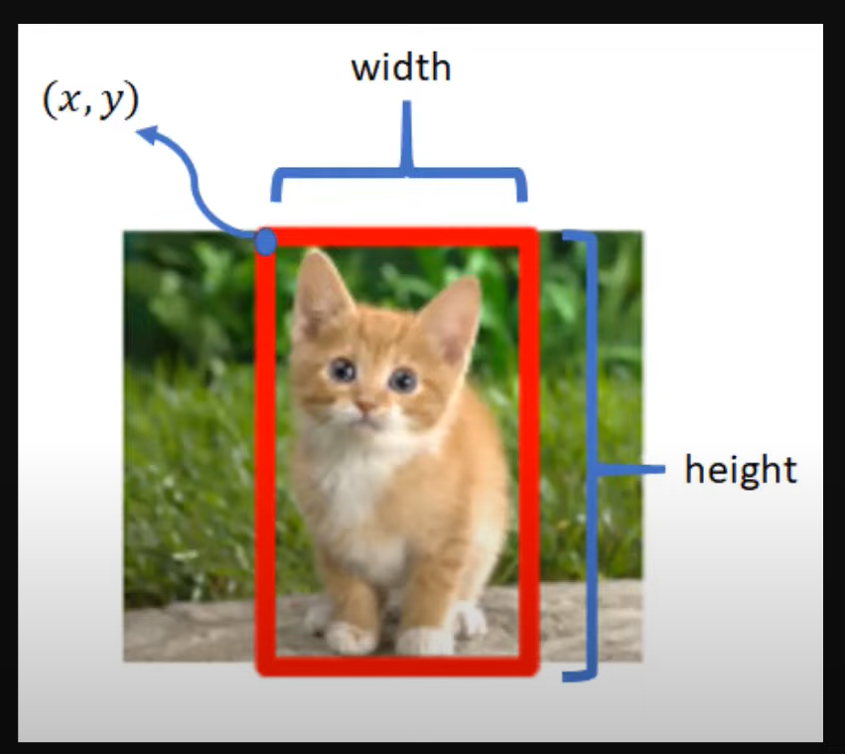
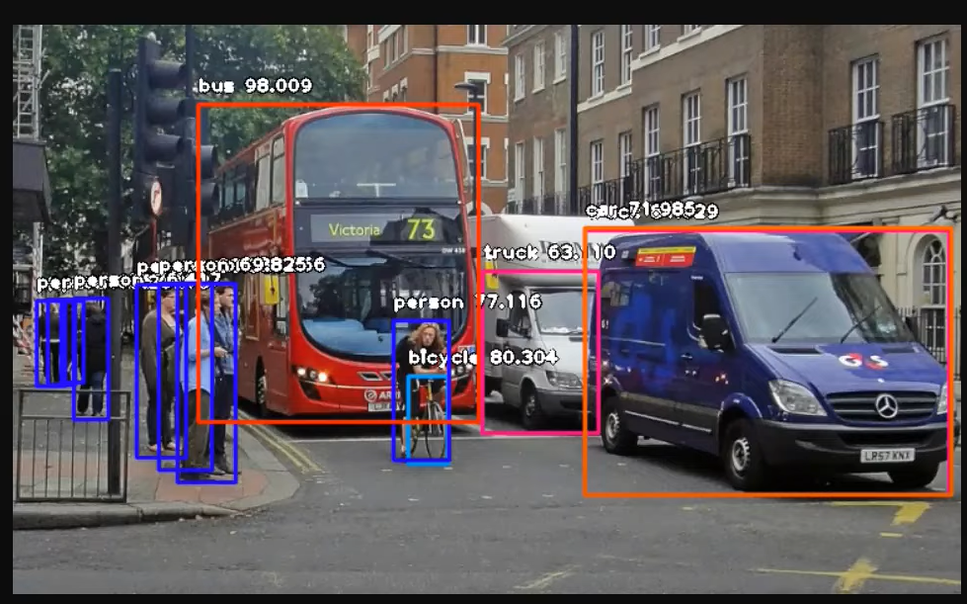
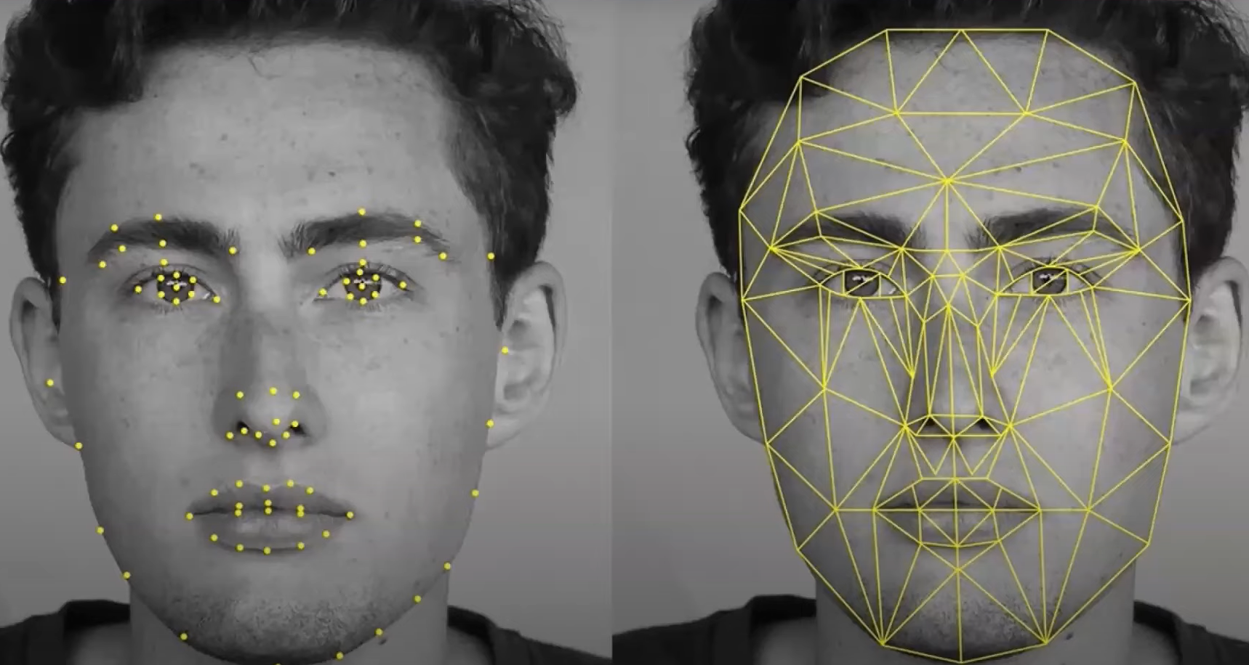
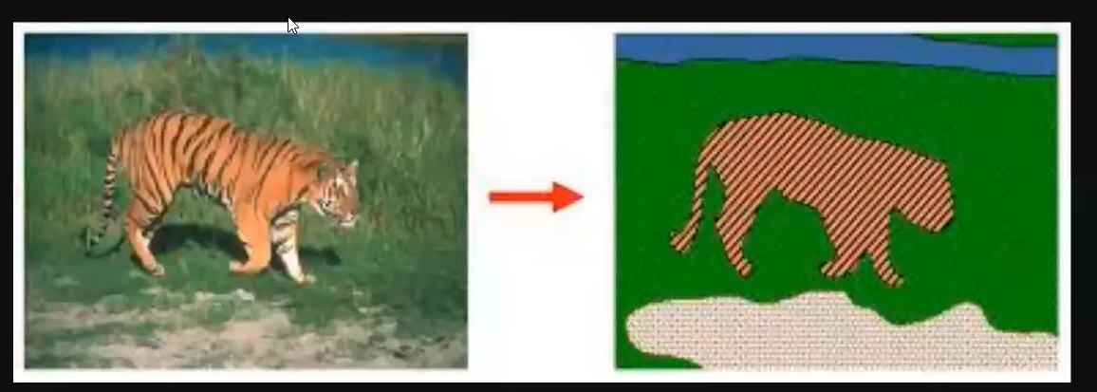
Image segmentaion.
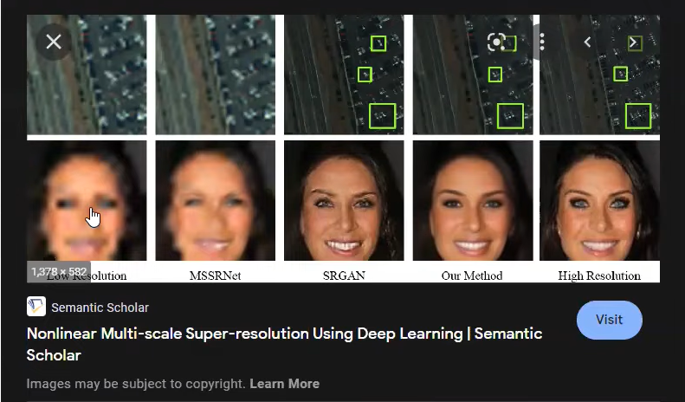
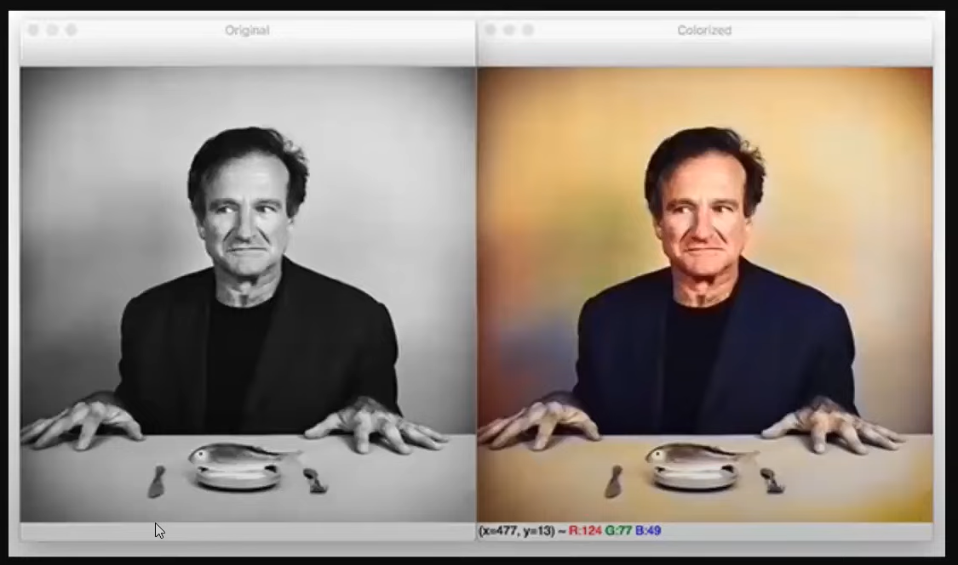
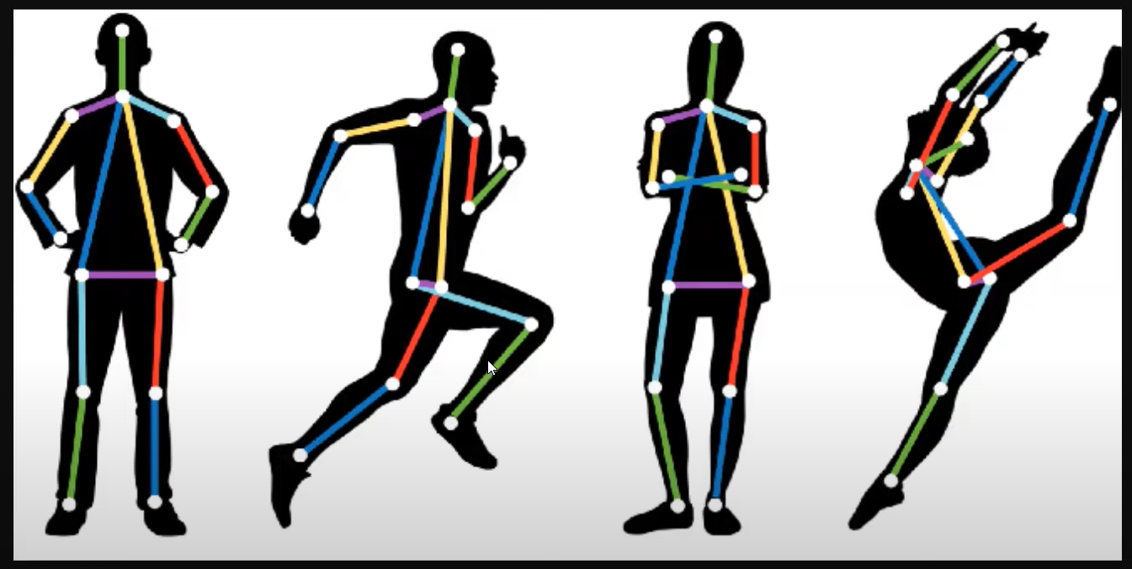
Movement recognition in game.

CNN Vs Visual Cortex | The Famous Cat Experiment | History of CNN
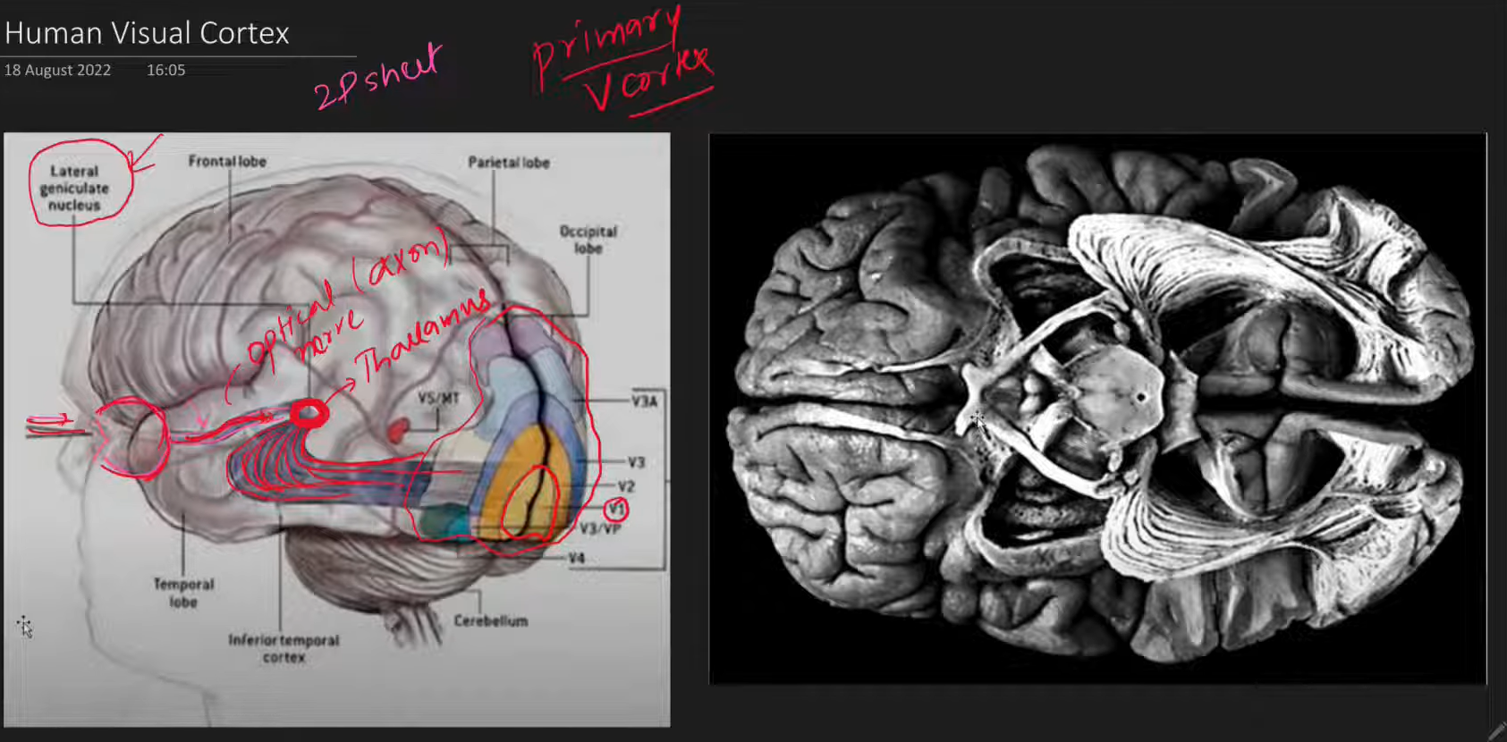
CNN Part 3 | Convolution Operation
Demo used in the video - https://deeplizard.com/resource/pavq7...
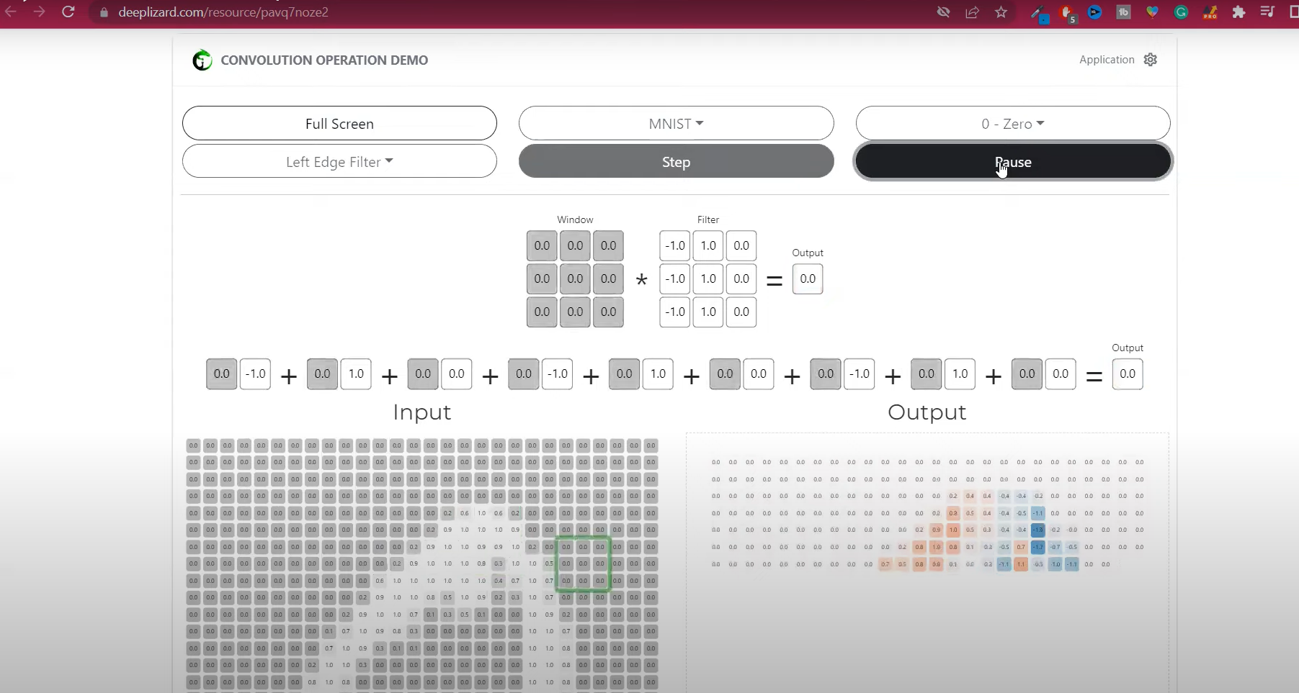
Use this visualization tool to observe.
Red is left while blue is right edge.
Ab Relu apply, +ve wala whi reh jaayega while -ve wala 0 ho jaayega.
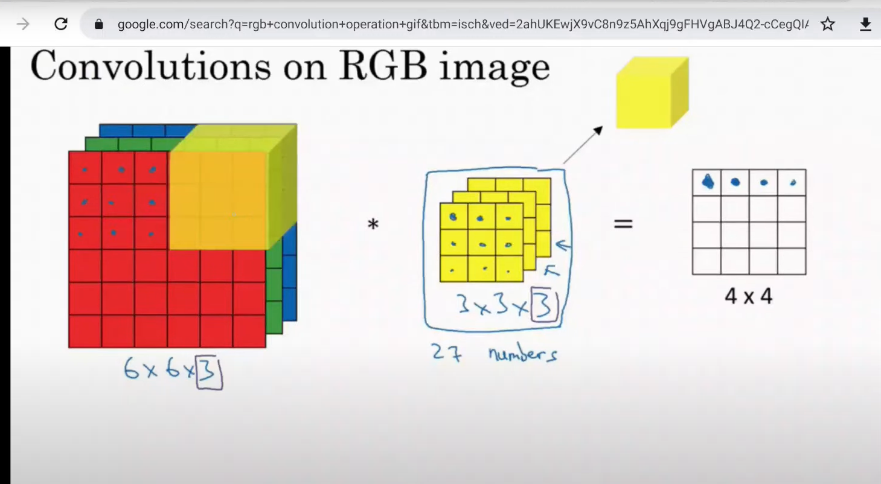

Padding & Strides in CNN | CNN Lecture 4 | Deep Learning
Code used - https://colab.research.google.com/dri...
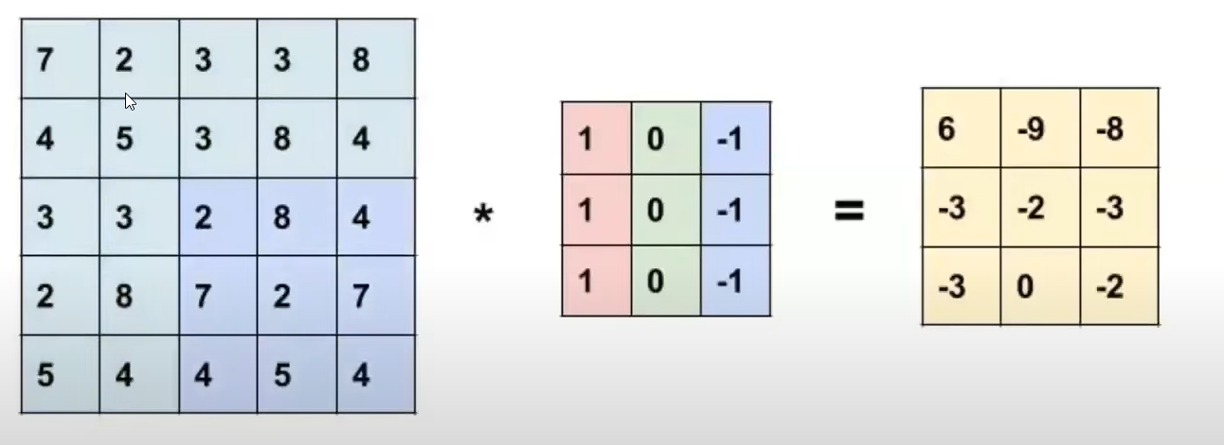
Problem with convolution.
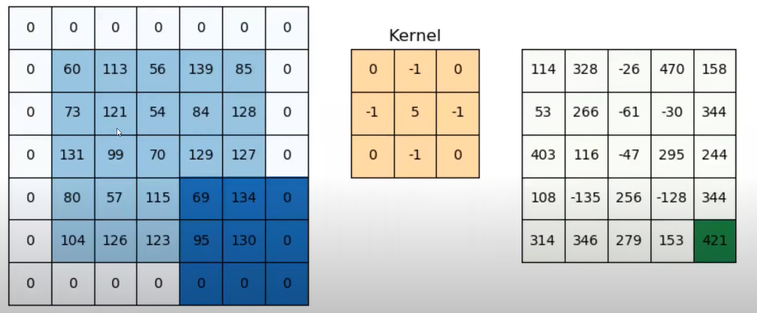
Padding apply karne ke baad.
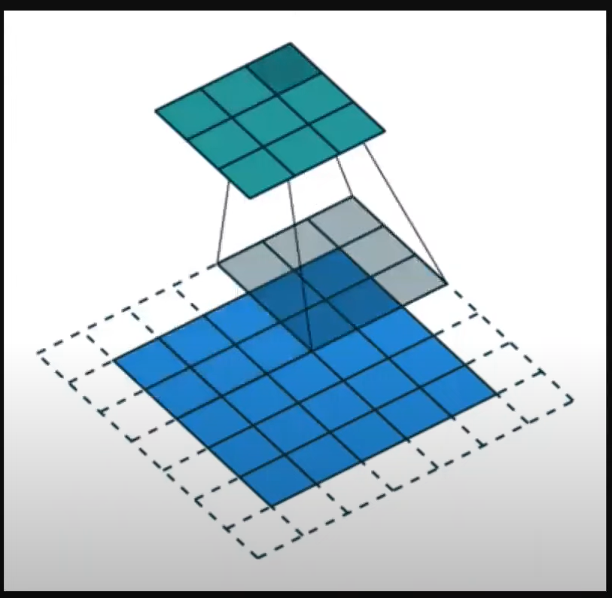
Why stride is important ?

Pooling Layer in CNN | MaxPooling in Convolutional Neural Network
Code - https://colab.research.google.com/dri...
Demo - https://deeplizard.com/resource/pavq7...
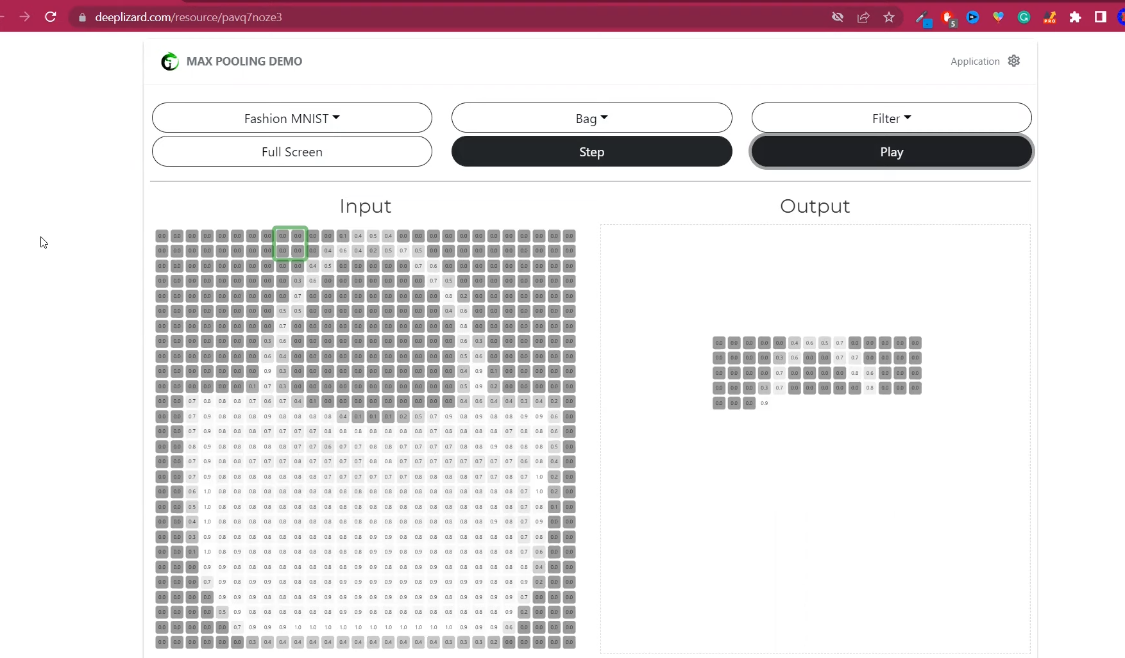Demo.
Check their playlist also.
Data Augmentation in Deep Learning | CNN
Read blog
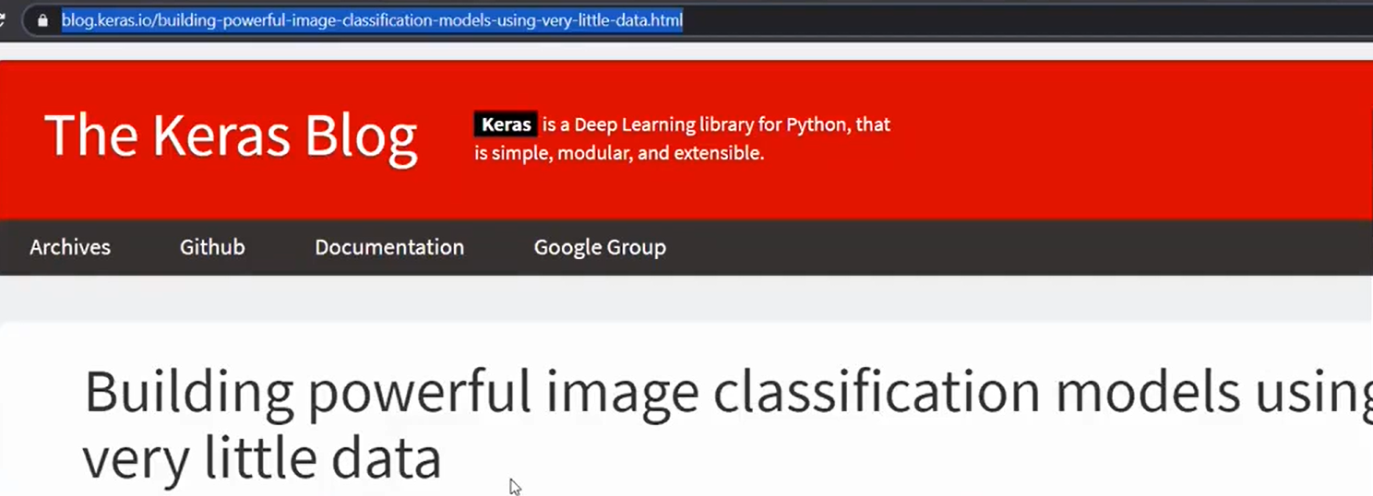
Augmentation: is creating image from image. By shifting, rotate, etc.
Augmentation reduces overfitting.

Pretrained models in CNN | ImageNET Dataset | ILSVRC | Keras Code
What does a CNN see? | Visualizing CNN Filters and Feature Maps | CampusX
Code was taken from this awesome blog post - https://machinelearningmastery.com/ho...
Code - https://colab.research.google.com/dri...

What is Transfer Learning? Transfer Learning in Keras | Fine Tuning Vs Feature Extraction
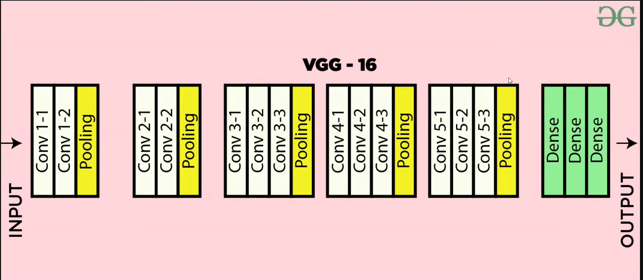
Keras Functional Model | How to build non-linear Neural Networks?
Dataset: https://www.kaggle.com/datasets/jangedoo/utkface-new
Read blog for more information: https://machinelearningmastery.com/keras-functional-api-deep-learning/
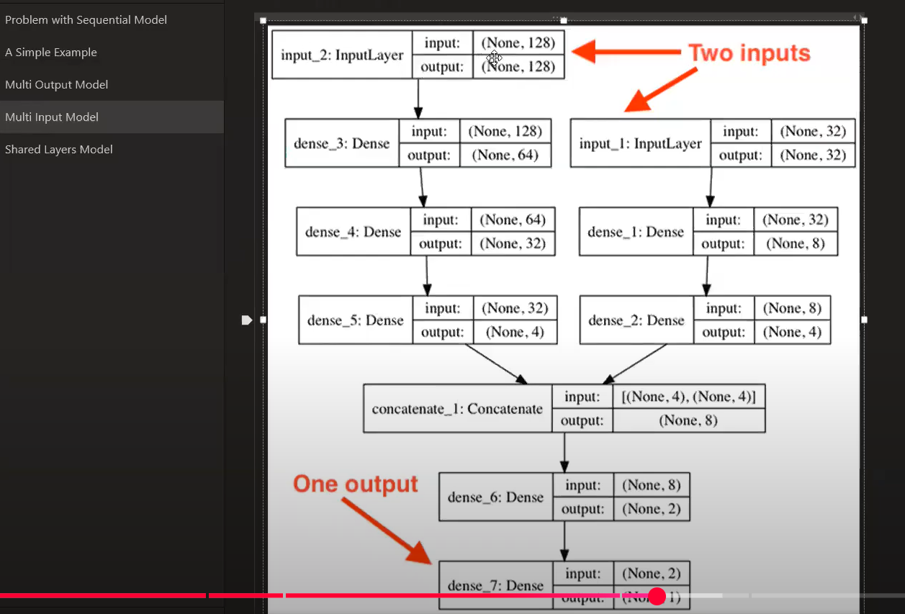
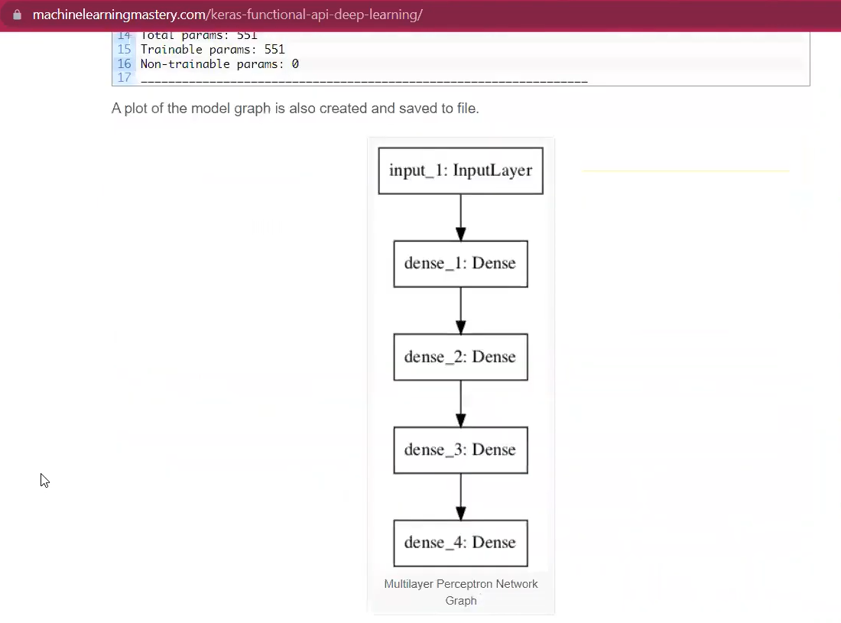
Why RNNs are needed | RNNs Vs ANNs | RNN Part 1
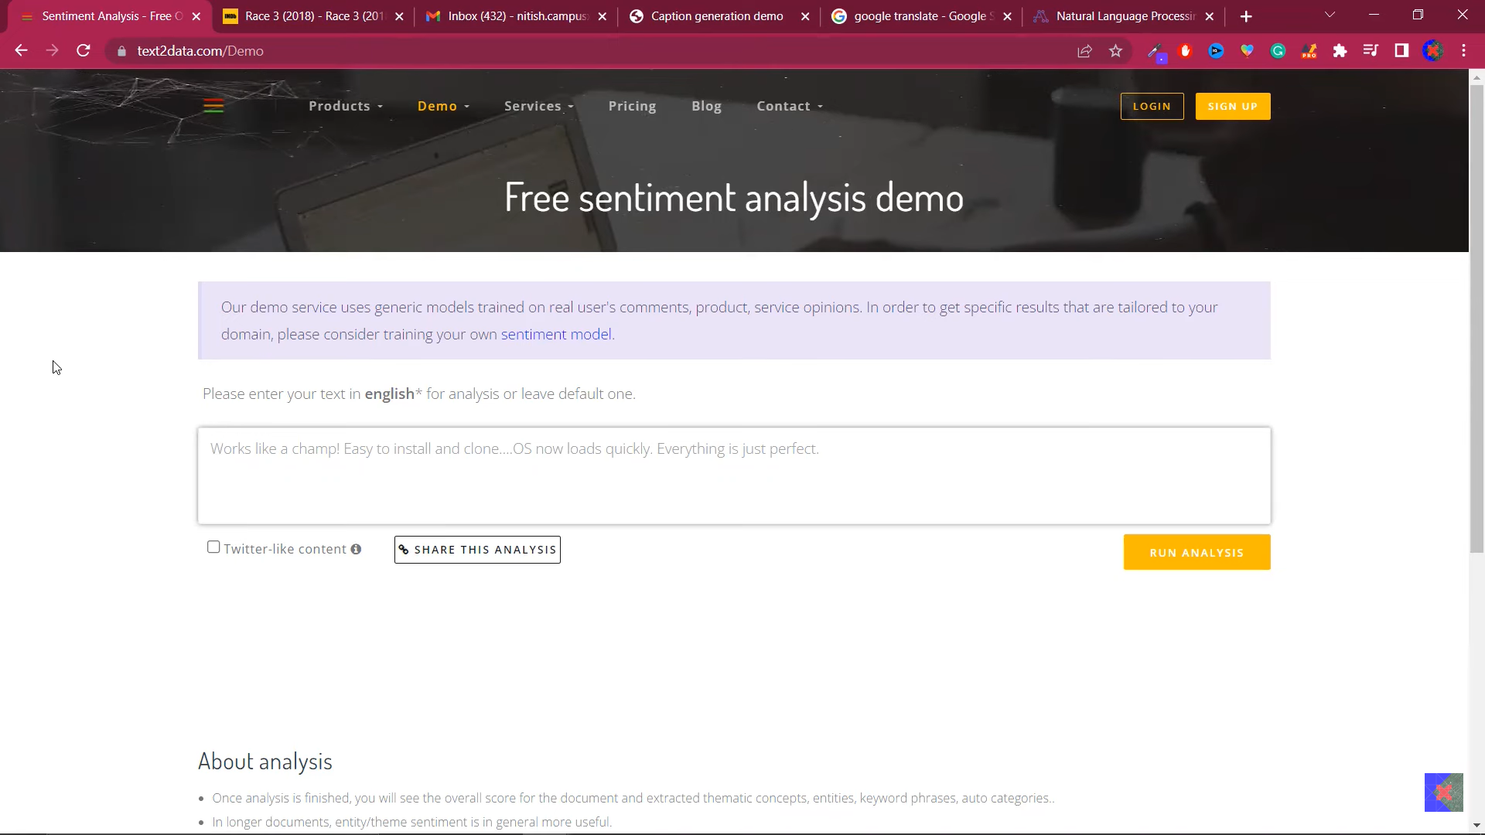

Recurrent Neural Network | Forward Propagation | Architecture
RNN Sentiment Analysis | RNN Code Example in Keras | CampusX

https://www.youtube.com/watch?v=JgnbwKnHMZQ&list=PLKnIA16_RmvYuZauWaPlRTC54KxSNLtNn&index=57&pp=iAQB
Code: https://colab.research.google.com/dri...
https://colab.research.google.com/dri...

Types of RNN | Many to Many | One to Many | Many to One RNNs
How Backpropagation works in RNN | Backpropagation Through Time
Problems with RNN | 100 Days of Deep Learning
LSTM | Long Short Term Memory | Part 1 | The What? | CampusX
Blog - https://colah.github.io/posts/2015-08...
LSTM Architecture | Part 2 | The How? | CampusX
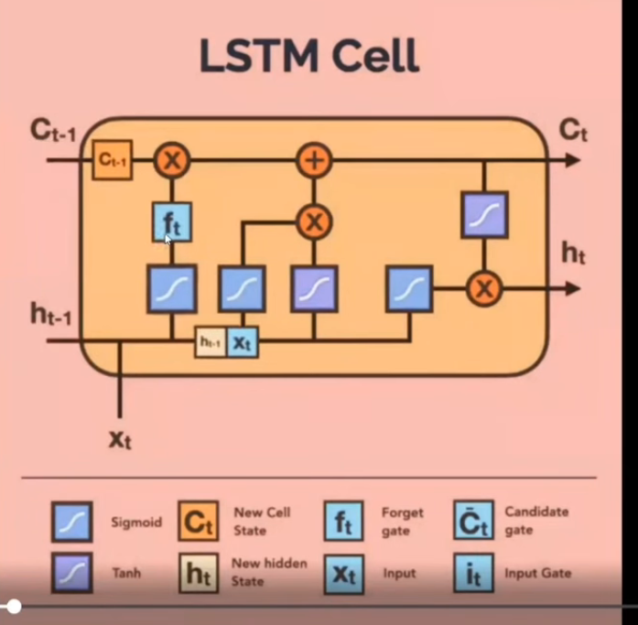
Code - https://colah.github.io/posts/2015-08...
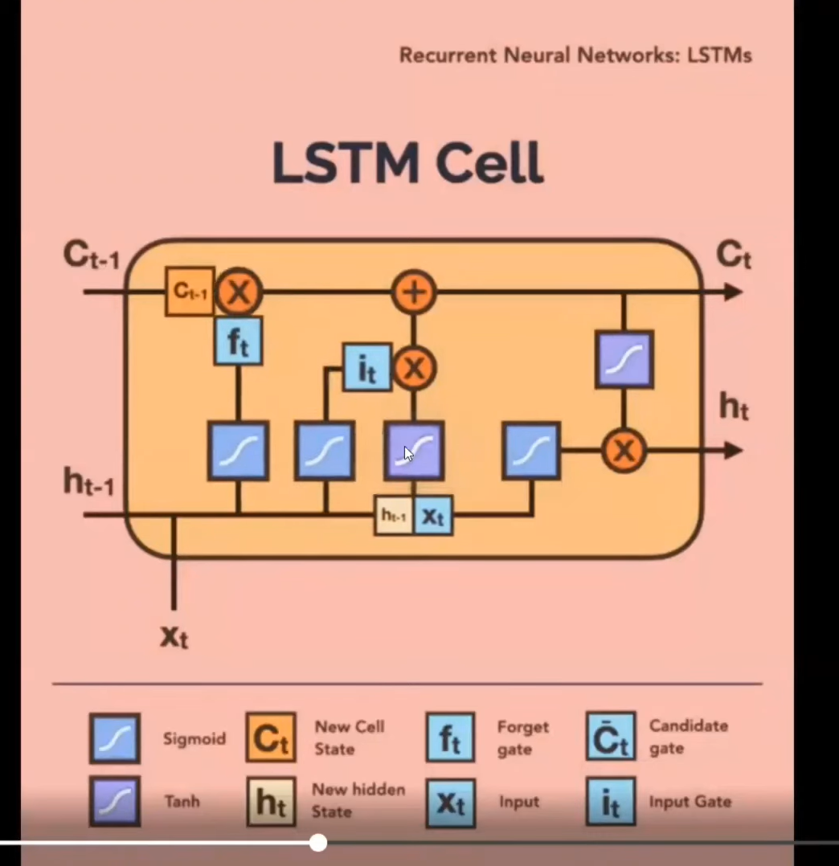
See this animation.
LSTM | Part 3 | Next Word Predictor Using | CampusX
Try this project
Gated Recurrent Unit | Deep Learning | GRU | CampusX
Deep RNNs | Stacked RNNs | Stacked LSTMs | Stacked GRUs | CampusX

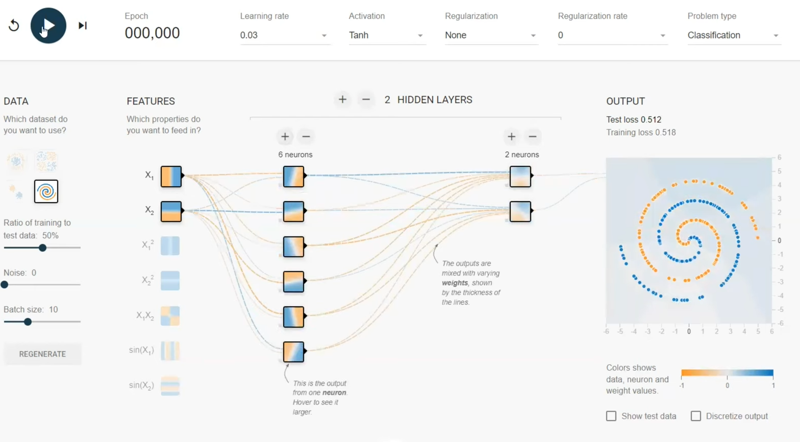

https://colab.research.google.com/drive/1c4eN4cPxajCpFG6yr1mAUi3sV1JaGLDY?usp=sharing

Bidirectional RNN | BiLSTM | Bidirectional LSTM | Bidirectional GRU
The Epic History of Large Language Models (LLMs) | From LSTMs to ChatGPT | CampusX
Encoder Decoder | Sequence-to-Sequence Architecture | Deep Learning | CampusX
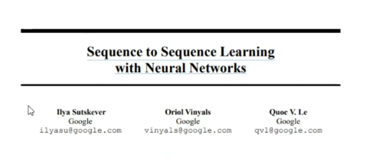
Read research paper.
Attention Mechanism in 1 video | Seq2Seq Networks | Encoder Decoder Architecture

Bahdanau Attention Vs Luong Attention
🔗Research Paper Links:
Bahdanau Attention - https://arxiv.org/abs/1409.0473
Luong Attention - https://arxiv.org/abs/1508.04025

